Tic Tac Toe Game:
Aim:
To write and implement a Python program for the Tic Tac Toe game.
Objective:
- To understand the basic concepts of the Tic Tac Toe game using Python.
- To represent the game board using a list.
- To implement player turns for two players, X and O.
- To check the winning conditions of the game.
- To identify whether the game results in a win or draw.
- To practice the use of functions, loops, conditional statements, and lists in Python.
Algorithm:
- Start
- Create a 3 × 3 Tic Tac Toe board using a list of 9 empty spaces.
- Display the game board.
- Set the first player as X.
- Ask the current player to enter a position from 1 to 9.
- Check whether the selected position is empty.
  - If empty, place the player's symbol.
  - If occupied, display "Position already occupied!" and ask again.
- Check whether the current player has three matching symbols in a row, column, or diagonal.
- If the player wins:
  - Display the board.
  - Display "Player X/O wins!"
  - Stop the game.
- If there is no winner, switch to the other player.
- Repeat the steps until all 9 positions are filled.
- If all positions are filled without a winner, display "Game Draw!"
- Stop.
Flow Chart:
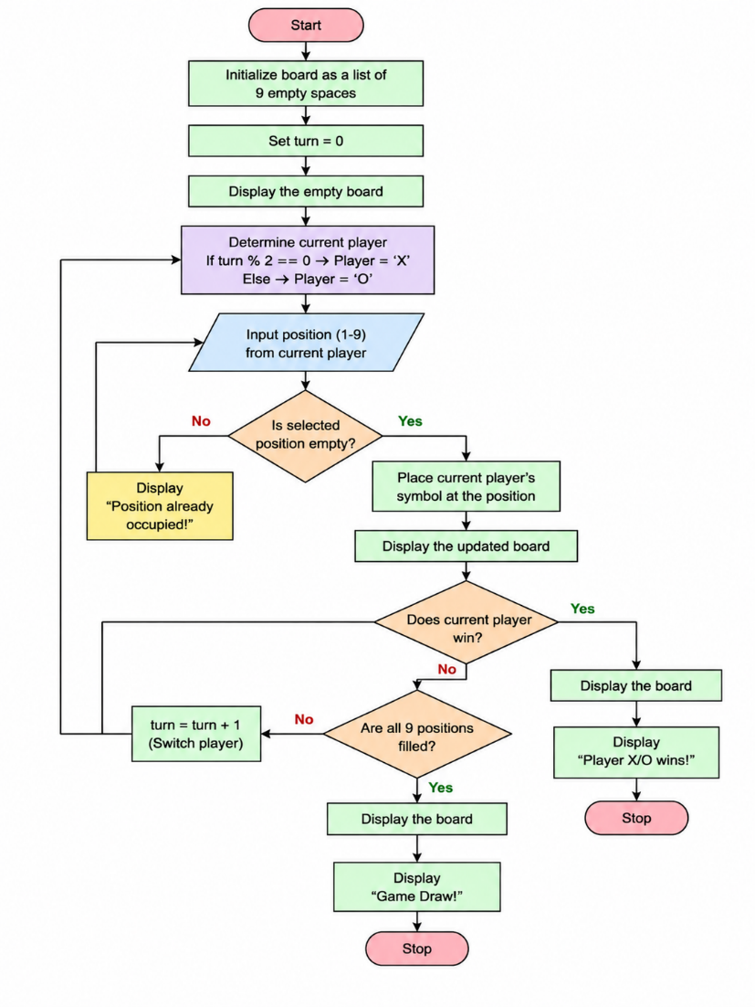
Python Code:
# Tic Tac Toe Game
board = [' ' for i in range (9)]
def display ():
print (board [0], '|', board [1], '|', board [2])
print ('--+---+--')
print (board [3], '|', board [4], '|', board [5])
print ('--+---+--')
print (board [6], '|', board [7], '|', board [8])

def check_winner (player):
win = [
[0,1,2], [3,4,5], [6,7,8],
[0,3,6], [1,4,7], [2,5,8],
[0,4,8], [2,4,6]
]
for w in win:
if board [w [0]] == player and board [w [1]] == player and board [w [2]] == player:
return True
return False
# Game
for turn in range (9):
display ()
player = 'X' if turn % 2 == 0 else 'O'
position = int (input ("Player " + player + ", enter position (1-9): ")) - 1
if board[position] == ' ':
board[position] = player
else:
print ("Position already occupied!")
continue
if check_winner (player):
display ()
print ("Player", player, "wins!")
break
else:
display ()
print ("Game Draw!")
Sample Output:
| |
--+---+--
| |
--+---+--
| |
Player X, enter position (1-9): 1
Player O, enter position (1-9): 5
Player X, enter position (2-9): 2
...
Player X wins!
Result:
